**Practical No-05**

* **Write a program that implements (with no preemption) scheduling algorithm.**

Code-

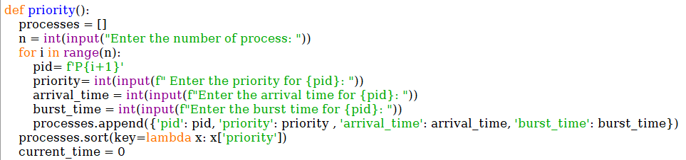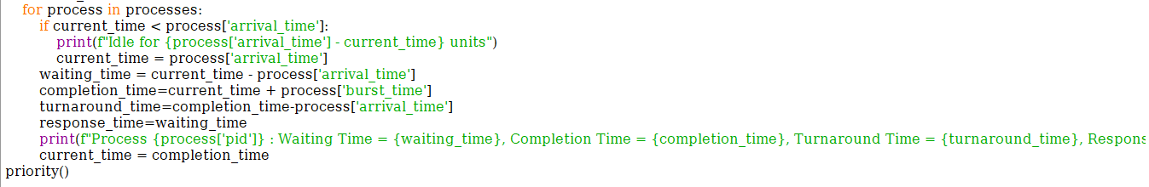

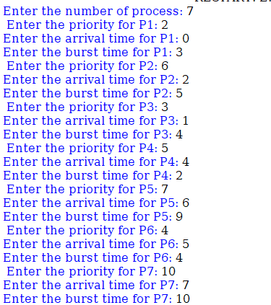Output-

